**Activity 2: Some critical thinking / discussion points about valid conclusions.**

The aim is to get them thinking about what can be concluded from a study, and to get them to move beyond banal critiques that are encouraged at A level (e.g. “but this study was done in 1972, and so isn’t valid any more”, or “but this study was only done on students from Plymouth”).

The critical distinction to get home is between what can factually be concluded from a study (that an effect was observed) and the underlying explanation of that effect (why the effect happened). Students often struggle to accept that an effect is real because they can think of other explanations of the effect.

This is not intended to be a discussion of replicability, or statistical significance. The activity links to some of the material on Andy’s critical thinking lectures, some of which the students will have had by this point. They will work with frequency distributions in a workshop next week, so they might need a gentle introduction here.

**Step 1:**

Get the students to say whether they agree with the following statements

All other things being equal, how much a person is likely to remember about a recent event is influenced by:

1. How old that person is
2. How drunk that person is
3. How much attention the person was paying at the time
4. The learning style that a person has.
5. How unusual or important the event is to that person

Can you think of any other factors that might influence how much is remembered about an event?

*Get them to generate 1 or two ideas and then share them. Generally, you should agree with them – many things can influence behaviour (memory).*

Once they have answered this, and you have discussed it, give the group Scenario 1, and get them to answer it in pairs.

Once they have all answered, get each of the pairs to say what they agreed with. (Past experience shows that they often struggle with these issues and want to agree with all if not most of the alternatives)

*Insert Scenario 1 activity here, presented as a separate sheet later in this document.*

The correct conclusion is (a), and nothing else.

Option (b) is rarely selected, but if it is, is an example of anecdotal evidence, and is not based on all the evidence obtained: use this as a discussion point about how Psychologists draw their conclusions vs how arguments are made in the media (e.g. Richard Branson is a successful businessman – to be successful you need to copy what he does), or in conversation (“My gran smoked 20 fags a day and lived to 120)”

Options (c) and (d) involve factors that influence the dependent variable, but which are irrelevant to the IV in this study, because randomisation was used. Options like these are often agreed with – and we often see these kinds of arguments in essays.

(Note, you could discuss whether we can draw ANY conclusion about ANYTHING in psychology because we can never control everything.).

Options (e) and (f) are about generalisation – make the point that all studies happen somewhere, using some materials. If you want to get them to think more, ask them where they would need to run the study in order to believe it, or what kind of materials they would need to use for them to think the results are important.

If you want to discuss this even more, get the students to consider Scenario 2 – an example where people “believe” the outcome, and so think the conclusion is valid. Here, because it is obvious that people won’t recall anything a year later, I expect that students will conclude that this study doesn’t need to be run under different conditions.

Note: if you don’t like this example, use another that taps into a clear underlying mechanism. (e.g. if the study was about the effects of eating foodstuffs on blood-sugar levels and found that eating 100g of chocolate raises blood sugar levels more than eating 100g of rice-cakes). Would that need replicating elsewhere?

**Scenario 1:** Imagine that you ran a study in which you tested Plymouth students on their memory for a study list of 10 words. You randomly allocate the students to two groups. One group were asked to study using method A, whilst the other group were asked to study using method B. Overall, you find that on average people studying using method A recalled more (Mean = 5.9/10) than those in Method B (Mean = 4.0 /10). The results looked like this:

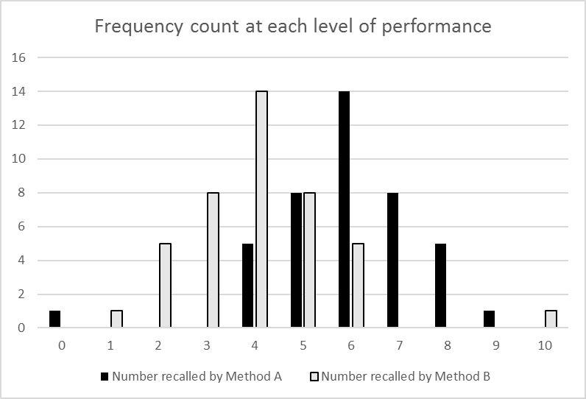

Counts for method A: 0=1, 4=5, 5=8, 6=14, 7=8, 8=5, 9-1

For method B: 1=1, 2=5, 3=8, 4=14, 5=8, 6=5, 10=1

What can you conclude from this study? You can agree or disagree with as many conclusions as you wish.

1. That for the study list, on average method A leads to better memory than method B.
2. Nothing, because the best performing person used method B, and the worst performing person used method A.
3. Nothing, because the study did not control for other factors that influence memory (such as how old the people were, how drunk the people were, or how much attention they were paying…)
4. Nothing because people with a verbal learning style are likely to do better than those with a visual learning style on this test.
5. Nothing because the study list wasn’t very unusual or important.
6. Nothing, because these were just Plymouth students

**Scenario 2:**  Imagine that you ran a study in which you tested Plymouth students on their memory for a study list of 10 words. You randomly allocate the students to two groups. One group were tested 1 minute after the list had been presented, and the other group were tested 1 year after the list had been presented. Overall, you find that people tested immediately have better memory (Mean = 5.9/10) than those tested after 1 year (Mean = 0/10). The results looked like this:

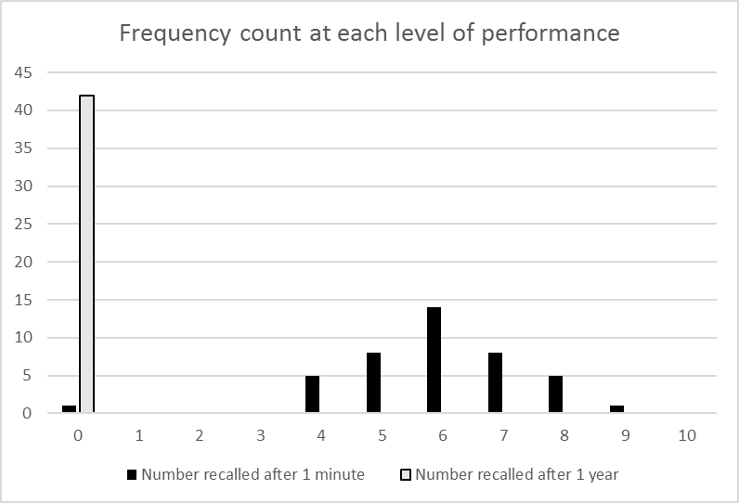

What can you conclude from this study? You can agree or disagree with as many conclusions as you wish.

1. That for the study list, people have better memory after 1 minute than they do after 1 year.
2. Nothing, because one person couldn’t even remember anything after 1 minute.
3. Nothing, because the study did not control for other factors that influence memory (such as how old the people were, how drunk the people were, or how much attention they were paying…)
4. Nothing because people with a verbal learning style are likely to do better than those with a visual learning style on this test.
5. Nothing because the study list wasn’t very unusual or important.
6. Nothing, because these were just Plymouth students